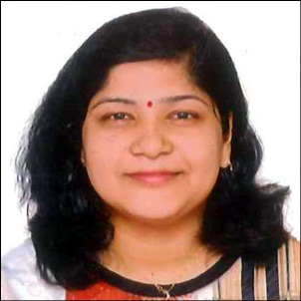
Malvika Dey
Mob No: 09406601705s
E-mail ID: malvikade@gmail.com,
Address: Flat no. 20, A7, Comfort zone,
Near Balewadi patha , Baner – Balewadi road,
Baner, Pune (Maharashtra) ,411057, India

Objective

To progressively enhance my knowledge and technical skills and utilize them for the growth of the Organization and Personal excellence.

Team Oriented

Quick Learner

Hard working

Positive Attitude
- Self motivated

Working Experience-

Jun 2013- Dec 2014 - Working as assistant architect with Ar. Vishal Parashar at Chaturbhuj Architect,

Indore (M.P)
Jan 2015-Feb 2016- Working as assistant architect with Ar.Madhuri Tomer at Innovative Design and
Solution, Indore (M.P.)
JUN 2017- FEB 2018- Working as In-House architect with Sneh Constructuion Group , Wakad, Pune
(Maharashtra)

Registered Form COA (CA/2013/61952)

Technical Skill -

Proficient in use of Autodesk AUTOCAD , SKETCHUP, MS OFFICE.
Knowledge of 3DS MAX
AREA OF INTEREST

Urban Designing, Landscape, Interior, Design Evolution, Climatic Designing, sketching and keen to learn various building services and client dealing.

Technical Training and Certificate -

Autodesk AUTOCAD at CADD-CAM Design centre, MG Road Indore (May-June 2010)

Autodesk 3DS MAX at CADD Centre Training Services PVT LTD, Aundh Pune (August- September 2016)

Training at-

CHATURBHUJ ARCHITECT, Indore (M.P)

Educational qualification-

Bachelor in Architecture, school of architecture, IPSA Indore, RGPV University, 2008-2013 (62%)
Higher Secondary Education, M.P. Board, 2007 (69.3 %)
High School Education, M.P. Board, 2005 (76%)

Extra Curricular Activities & Achievements

Worked & Served in “ARGHA – Zonal NASA Convention 2011” hosted by School of Architecture IPS Academy, Indore.

Worked in organizing committee’s for several function’s and program’s held at SOA, IPS Academy

Personal Profile
Name | Malvika Dey
Date of Birth | June 20th, 1990
Husband Name | Nilotpal Deb
Nationality | Indian
Linguistics | English, Hindi, Bengali
Marital status | Married

Referances:-

Ar. Vishal Parashar
Chaturbhuj Architect, Indore
chaturbhuj.architect@gmail.com
09826682300

